**Age Code/ Mass Sensitivity/ ExoDMC Instructions**

**Important Links:**

<https://github.com/shinkley/mphys-titanic>

<https://github.com/mbonav/Exo_DMC>

Instructions written by Sophia Stasevic, if you experience any problems feel free to email me at: [**sophiastasevic99@hotmail.com**](mailto:sophiastasevic99@hotmail.com)

**-------------------------------------------------------------------------------------------------------------------------------**

**Age Code**

1. Follow instruction for the Age Code in **mphys-titanic/Common/Age Code/** (<https://github.com/shinkley/mphys-titanic/tree/master/Common/Age%20Code>) (below is a brief summary of instructions):
2. You will need to have '**age_analysis.py**' and '**MIST_Gaia_vvcrit0.4.iso.cmd**' in the same directory
3. Go to the **Gaia DR2** catalogue in **VizieR** (<https://vizier.u-strasbg.fr/viz-bin/VizieR-3?-source=I/345/gaia2&-out.max=50&-out.form=HTML%20Table&-out.add=_r&-out.add=_RAJ,_DEJ&-sort=_r&-oc.form=sexa>)
4. Input your star name into the search bar with a target dimension of 5 arcsec, and check the boxes for **Plx, e_Plx**, **Gmag**, **e_Gmag**, **BPmag**, **e_BPmag**, **RPmag**,and **e_RPmag** and press submit.
5. Create a text file called ‘**starnames.txt**’, with the information formatted like below: 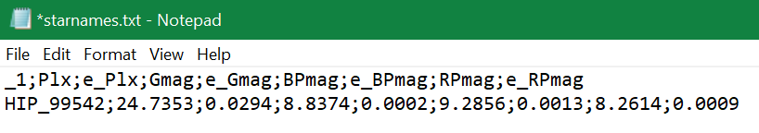
6. Running the **age_analysis.py** code should then give you the output, **ages.txt**, that contains the star name, age, upper error, and lower error.

**-------------------------------------------------------------------------------------------------------------------------------**

**Mass Sensitivity Code**

**On your own computer:**

1. Mass sensitivity code is available in **mphys-titanic/Common/mass_sensitivity/** (<https://github.com/shinkley/mphys-titanic/tree/master/Common/mass_sensitivity>)
2. You will need to have ‘**mass_sensitivity.py**’, ‘**baraffe_final.txt**’, and a folder titled **‘inputs’** containing the **curve output file** of your star in the same directory. You will also need to create the empty folder: **‘outputs’**.
   1. The curve output is the text file produced from running the Project Script on your star, and can be the output from LLSG, PCA, annPCA, etc. The file name should be of the form: “[star name]_[method]_contrast_curve_[epoch]_new.txt” **(e.g. HIP_99542_RDI_contrast_curve_2012oct29_new.txt)** however this is a relic of the naming of the RDI code output, and can be changed on **line 49.**
3. Check curve_outputs file for your star and change the variables in **mass_sensitivity.py** accordingly:
   1. If it contains **5 columns** of data, **separation_column=3** and **contrast_column=0**
   2. If it contains **7 columns** of data, **separation_column=4** and **contrast_column=1**
4. Make a csv (Excel) file called **‘star_names.csv**’ that contains the **star name**, **epoch**, output from the **age code**, **distance**, and **apparent K-band magnitude** (can be found on the Keck Observing Spreadsheet in the **DateForCurveConversion** tab)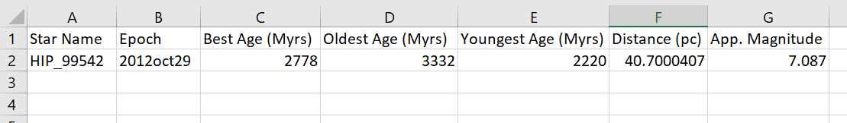 (don’t include first row with header information)
5. Run **mass_sensitivity.py**, which should save sensitivity curve plot and a data text file to the **outputs** folder.

**On analysis:**

1. Go to the **Mass_Sensitivity** directory in DangerZone, if you’re in your home directory you will need to type: **cd ../../data/shinkley/Keck_Data/completed_stars/DangerZone/Mass_Sensitivity/**
2. The contrast curve file needs to be in the RDI folder for the star on DangerZone (e.g. **HIP99542/RDI**) and have the same name format as in previous **step** **2a** (note: this is for the ADI/RDI outputs of RDIv5.py that have then been calibrated using Contrast.py, but I believe RDIv6.py doesn’t need to be calibrated, and so the curve data will not have the additional “_new” in their file name, so edit **line 50** of the script accordingly)
3. Repeat **step 4** from above, but save the csv file in the Mass_Sensitivity directory
4. Run using: “python mass_sensitivity.py [file containing star names+data] [method]” **(e.g. python mass_sensitivity.py star_names.csv RDI)**
   1. Both plots and data files will be saved in the **‘outputs’** folder

**-------------------------------------------------------------------------------------------------------------------------------**

**ExoDMC**

**On your own computer:**

1. Download **RunDoubleExoDMC.py** and **DoubleExoDMC.py** from **mphys-titanic/ExoDMC** (<https://github.com/shinkley/mphys-titanic/tree/master/ExoDMC>) (may still need to install the package by typing **pip install ExoDMC** in the console)
2. In the directory containing the scripts, you will also need an **‘inputs’** folder containing the output from the mass sensitivity script, and the same csv file containing the **list of stars** as for the mass sensitivity script. You will also need to create the empty folders: **‘outputs’** and **‘plots’**.
3. Edit **lines 189-191** of **RunDoubleExoDMC.py** to correspond to the name of your csv file, as well as the post-processing method used for the data.
   1. If you wish to compare two different methods, **method_1** detection probability will be plot in full, with the contours for 68% and 95% probability, and only those same contour lines will be plot for **method_2**
   2. If you only wish to plot one method, simply set **method_2** as **‘SINGLE’**
4. Run **RunDoubleExoDMC.py**, which will save the detection probability map to the **plots** folder, and data text file to the **outputs** folder.

**On analysis:**

1. Go to the **Detection_Probability** directory in DangerZone, if you’re in your home directory you will need to type: **cd ../../data/shinkley/Keck_Data/completed_stars/DangerZone/Detection_Probability/**
2. Install the DMC module by typing **pip install ExoDMC**
3. Copy your list of stars csv file to the current directory using: **scp ../Mass_Sensitivity/[file name].csv .**
4. Run ExoDMC using the command: **python RunExoDMC.py [csv file] [method 1] [method 2]**
   1. As with above, to only use one method in the plot, input **method 2** as **‘SINGLE’** e.g. **python RunExoDMC.py star_names.csv RDI SINGLE**
   2. Data text files are saved to the **‘outputs’** folder, and plots to the **‘plots’** folder.

**Possible errors:**

* If you receive the error: **‘IndexError: too many indices for array:’**, this is because the csv file requires at least 2 lines of data. If you only wish to run it on one star/epoch, just duplicate the line for that star/epoch in the csv file.
* If your probability maps show a “double tongue”, i.e. a high detection probability dip at lower separation, before exhibiting the expected shape, this will be caused spikes in the contrast curve, normally within the radius of the coronagraph, making the mass sensitivity go to infinity. For a quick fix you can remove the first few lines of all the data that will contain these spikes using the code **data=np.delete(data, (0,1,2,...), axis=0)** directly after the line **data=np.loadtxt(path)** in the **run_exo_dmc** function
  + In the future, it may be beneficial to just remove the parts of the contrast curve within the coronagraph before converting to mass sensitivity.
* I’ve noticed reading the csv files can sometimes be very particular. If you’re getting errors at that stage I recommend using a star_names.csv file that already exists on analysis, renaming it, and then pasting your star information while matching the destination formatting.